

UNDERWATER ROV CHALLENGE
Answer Sheet

INTRODUCTION
The Giant Australian Cuttlefish (Sepia apama) is among the largest cuttlefish in the world, can grow to 50cm and weigh up to 10kg. They can be found all along the Southern Coast of Australia from as far north as Brisbane in Queensland to Shark Bay in Western Australia.
Cuttlefish require rocky ledges or other hard substrates under which they can attach their eggs. Every winter there is a unique spawning aggregation of cuttlefish at reef at Point Lowly near Whyalla, South Australia, within northern Spencer Gulf which has few other reefs. . Marine scientists perform surveys each year to monitor this Spencer Gulf population .
Over the years, several methodologies have been used to monitor the cuttlefish including scuba diving, towed underwater camera and remotely operated vehicles (ROVs) with specialized software and stereo video cameras.

DESCRIPTION OF ACTIVITY
As an up-and-coming marine scientist, you have been tasked with analysing a video transect from one of the monitoring sites at Point Lowly recorded by the ROV. The site is called WOSBF (shallow) and the transect is transect number 1. You have been asked to count the number of cuttlefish and perform some calculations to quantify the cuttlefish density on this transect.
TASK 1
Task number 1: Cuttlefish Count
Count the cuttlefish in the video transect without stopping the video, simulating real-time video analysis in the field. Take note of your count using a pencil and paper, or an excel spreadsheet.
You will need the results from the count for completing the other tasks.
Number of Cuttlefish on Transect 1:

TASK 2
Task Number 2: Cuttlefish Density
Calculate the cuttlefish density on this transect by dividing the number of cuttlefish by the area covered (Density = count / area m2). The area covered in the transect was 50m2.
Density of Cuttlefish on Transect 1:

CHALLENGE COMPLETE!
Awesome job, you’ve completed the Underwater ROV Cuttlefish challenge and can now submit your answer. Make sure you do, because we’ve got an awesome prize where you could spend a day driving underwater robots! To submit your answer, register for the challenge here.

LOOKING TO CHALLENGE YOURSELF EVEN MORE?
These tasks below are not part of the challenge, but if you’re looking to test your newly acquired “cuttlefish counting” skills then check them out:

TASK 3 – extra activities just for fun
Task Number 3: Total Survey Area Count
Calculate the Count of Cuttlefish across the entire Survey Area including all sites. This task requires you to complete the missing data in Table 1 and then populate the missing data in Table 2 in order to calculate the Total Survey Area Count at the bottom of Table 2. Note that Table 2 provides count and area data from all other sites in the Survey Area. Fill in all the boxes that are yellow!

TASK 4
Task Number 4: Survey Area Biomass Calculation
Calculate the estimated total biomass of the Survey Area. This can be calculated using the below formula. For this calculation, assume that average Cuttlefish weight is 503g per individual and the total number of cuttlefish is found in Table 2.
Survey Area Biomass = Average individual weight x Total Number of Individuals

Table 1: WOSBF (shallow) Transect Data

Transect # | Cuttlefish Count | Transect Area (m2) | Density
1 |  | 50
2 | 25 | 162
3 | 28 | 143
4 | 31 | 145
Total for WOSBF (shallow) Site

Table 2: Survey Area Data

Site | Transects | Site Area (m²) | Cuttlefish Count | Site Density (per m²)
False Bay | 4 | 594 | 38 | 0.063
Black Pt (shallow) | 5 | 786 | 137 | 0.180
Black Pt (deep) | 4 | 645 | 93 | 0.139
Third Dip (Shallow) | 4 | 677 | 38 | 0.059
Third Dip (deep) | 4 | 637 | 13 | 0.020
WOSBF (shallow) | 4
WOSBF (deep) | 4 | 609 | 63 | 0.099
Stony Pt (Shallow) | 4 | 580 | 45 | 0.077
Stony Pt (deep) | 4 | 593 | 15 | 0.026
Santos Tanks | 4 | 568 | 1 | 0.002
Point Lowly West | 4 | 515 | 0 | 0.000
Pt Lowly Lighthouse | 5 | 611 | 3 | 0.003
Pt Lowly East | 4 | 607 | 1 | 0.002
Fitzgerald Bay | 4 | 495 | 4 | 0.009
Backy Pt | 4 | 562 | 7 | 0.008
Survey Area Total | 62

WANT TO KNOW EVEN MORE ABOUT HOW MARINE SCIENTISTS COUNT CUTTLEFISH?!
ADDITIONAL READING – Survey Method Background
The data we are analysing was captured by Geo Oceans using a vLBV 300 ROV fitted with a stereo video camera system. The data has been modified slightly for the purposes of this activity.
The field team recorded the area covered in the transect in real-time using GO Visions software. The software uses an algorithm which calculate the GPS distance covered and the ROV height off seafloor to quantify the monitoring area coverage. For the purposes of this activity, site area for WOSBF (shallow) has been slightly adjusted to simplify the activity.
For this activity we have just calculated Total Survey Area counts for use in our biomass calculation, whereas for an actual monitoring program we would calculate abundance by extrapolating the site data across the entire spawning habitat area.
During the monitoring program, the stereo cameras were used to measure the size of each cuttlefish. Density results across all sites were extrapolated across the entire area to estimate abundance of the entire cuttlefish population. Size scale and a size to weight ratio were then used to estimate biomass of the entire population.
The size of each cuttlefish is measured using a stereo camera system mounted on the ROV and software called EventMeasure.
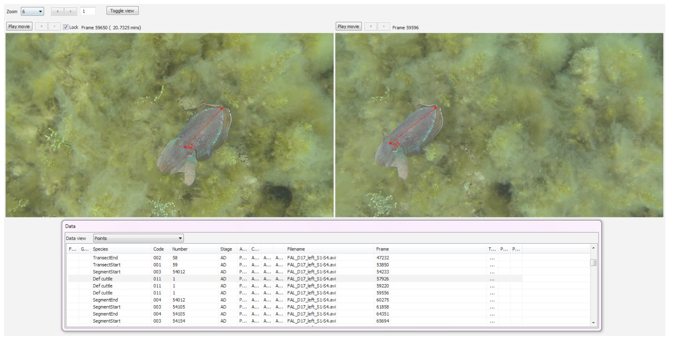
Figure 1. Screenshot showing EventMeasure software being used to measure the mantle length of a cuttlefish.

A size to weight ratio is then used to calculate the average weight of the cuttlefish (Hall 2002). Assuming that the sex is unknown, cuttlefish weight is determined as follows:
- Weight (g) = 0.0006 x Mantle Length (mm)^{2.675}
When calculating biomass, this formula is normally applied to calculate the weight of each cuttlefish, however for our exercise above we have simplified the activity using a single average weight.
For this activity we have calculated biomass only for the Survey Area, whereas in an actual monitoring program we would use the entire spawning habitat abundance estimate to determine biomass of the entire spawning aggregation.
For more information on the Giant Australian Cuttlefish and the monitoring program you can find a lot of interesting information and previous reports on the PIRSA website here: https://www.pir.sa.gov.au/fishing/recreational_fishing/cuttlefish
DISCLAIMER
Please note that the data provided in this activity is for educational purposes only and has been modified to suit the activity and target audience. Please don’t rely on these data for any purpose other than the intended educational activity. The PIRSA website link above includes links to several monitoring reports with actual survey data from Giant Australian Cuttlefish monitoring programs at Point Lowly in South Australia.

